Kids Tracksuit measurements - Tops
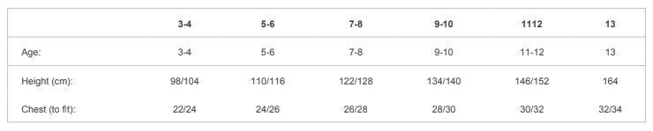
Trousers
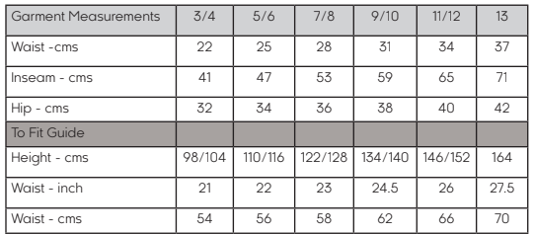

Adults Tracksuit measurements – Tops
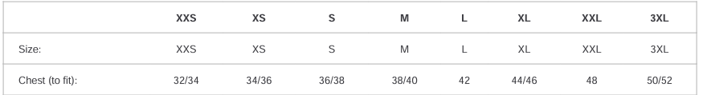

Trousers
